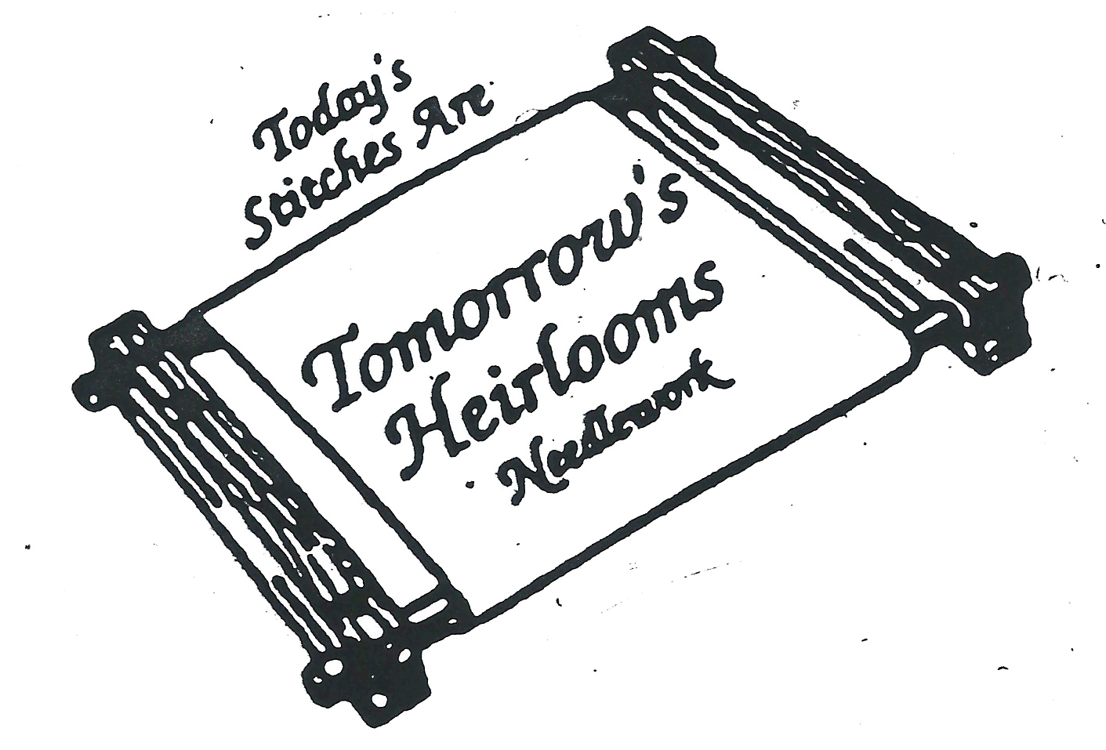
We know you’ve all been anxious for us to get the registration email for June 2022 out to you all! We can’t wait to spend the day with Vickie Jennett. This will be Vickie’s first visit to us, and we are just thrilled we could make this happen! We know you will love with what we have in store for you! As past attendees, you getting an advanced registration opportunity. We will be sending out general registration first thing Tuesday morning, the 19th of April, and we expect this to fill, so don’t delay if this is a retreat you want to attend.
We will be capping the class size, so we recommend signing up quickly if you are wanting to attend. As a reminder, we do not allow "ghosting" of our events, as we like to see everyone in person, so kits are not available for purchase only. YOU MUST ATTEND TO RECEIVE YOUR KIT. Please don’t put us in the awkward position to have to tell you no. Thanks for understanding.
Pam and I are excited to be able to hold this event at the Double Tree hotel! We love the location’s convenience, and the new management has made some great improvements. Due to Covid, our numbers allowed will be smaller, but social distancing and safety protocols promise a safe event.
As usual, we ask that you trust us and your divinely talented designer to amaze you with her fabulous design. We won’t have pictures ahead of time but know that you will enjoy spending the day with Vickie and you will be thrilled with the reveal on Saturday morning.
For this event, we will NOT have a boutique on site at the hotel, but we will have a trunk show at the shop that weekend. We will have a meet and greet for attendees on Friday evening from 7:00 - ??? at the shop and the shop will be open extended hours on Saturday and special Sunday morning hours for those last-minute must-haves.
Meals will be on your own. There are lots of options within a 10–15-minute radius of the hotel that will satisfy everyone’s dining choice. We are happy to give suggestions if you need one!
We expect this to fill quickly so don’t be surprised if you are placed on a waiting list. We can’t “oversell” our room due to Covid limitations, and this is never our “m.o.”, as we always like to keep the class size on a smaller scale, so everyone gets some time with Vickie.
A note about COVID restrictions: In Illinois, we are “fully open”, but with the Covid still around, we will continue to be cautious. We appreciate your understanding, and we will do our best to get everyone in and out in a safe manner. Additionally, masks are not required for vaccinated people, but are recommended for those not vaccinated. Pam and I will not be the “mask police”, so, if you feel this is something you will not be able to comply with, perhaps this retreat is not one for you. So many are anxious to get back to some normalcy, that we want those who are willing to follow our state guidelines to feel comfortable in the environment we are able to provide.
Accommodations are available at the Doubletree Guest Suites and Conference Center in Downers Grove, Illinois. Centrally located between O’Hare International and Midway Airport, the hotel is also nestled conveniently near local expressways for easy access from any mode of transportation the stitcher chooses to use. The block is NOW OPEN for reservations. By the end of May, the rooms will be released back into the hotel’s regular inventory. We recommend calling the hotel directly and asking for the Tomorrow’s Heirlooms block. Call 630.971.200 and tell them you are with the Tomorrow’s Heirlooms event. You may also book online using the link below. Room rates $120.00 for a king room per night, and you, as usual, will book yourself. Each suite features a separate living room and bedroom, refrigerator, microwave, coffeemaker, and hairdryer. If you have issues, please feel free to let us know and we can try to help. But do remember, we aren’t in the hotel biz and the best we can do contact our event manager.
Hotel: DoubleTree Suites by Hilton & Conference Center Chicago - Downers Grove
Group Name: Tomorrow's Heirlooms
Booking Link: https://doubletree.hilton.com/en/dt/groups/personalized/O/ORDWBDT-TIR-20220624/index.jhtml?WT.mc_id=POG

When: Friday, June 24,2022 ---Meet and Greet Special Event AT TOMORROW’S HEIRLOOMS
7:00 p.m. to ??? (Due to COVID, we will not be able to provide snacks at this event, as we have done in the past.)
Saturday, June 25 --- Class ---9:30 a.m. – 4:30 p.m.
Sunday, June 26 --- Class --- 9:30 a.m. – 12:00 p.m.

Where: Doubletree Guest Suites & Conference Center in Downers Grove, Illinois

Cost: $350.00----includes Saturday and Sunday projects
A $50.00 nonrefundable deposit is required at time of registration. ***Please note, that there can be NO refunds/cancellations after AUGUST 15, as supplies will have been ordered and kits prepared.
The first payment of $150.00 is due by May 1, 2022.
The second payment of $150.00 is due by June 1, 2022.
Registration Closes: When it is filled or May 1, 2022
____ I have read the above information and understand the deposit of $50 is non-refundable and that my kit will not be available should I not attend the event in June.

Registrations may be dropped off, emailed or phoned in to: (NOTE THE ADDRESS)

Tomorrow’s Heirlooms, Inc.
20 N Park Boulevard
Glen Ellyn, Illinois 60137
Telephone: 630-790-1660
Email: tomheirnews@gmail.com

Attendee: ________________________________________

Telephone (daytime): ___________________________

Email Address: ___________________________________

Check No. ________________

Credit Card No. ___________________________________Exp. Date: ____________CVV/CID __________
House Number: _______________ Zip code: ____________

****We will be contacting you by email whenever possible, so please be sure we have an email address for you that you check regularly!

****Unless you instruct us differently, we will charge the credit card we have on file on May 1 for the balance due. Reminder: No refunds or cancellations will be granted after May 1.

